CS 255 System Design Document
DriverPass System
Southern New Hampshire University | CS 255: System Analysis and Design

UML Diagrams

UML Use Case Diagram
The use case diagram below represents the full scope of the DriverPass system. It identifies all actors — Customer, Staff, Secretary, Administrator (Owner), IT Officer, Driver, and the external DMV Updates System — and maps each actor to the system functions they can perform. The diagram demonstrates how DriverPass meets the client's needs by supporting scheduling, testing, account management, reporting, and DMV integration.

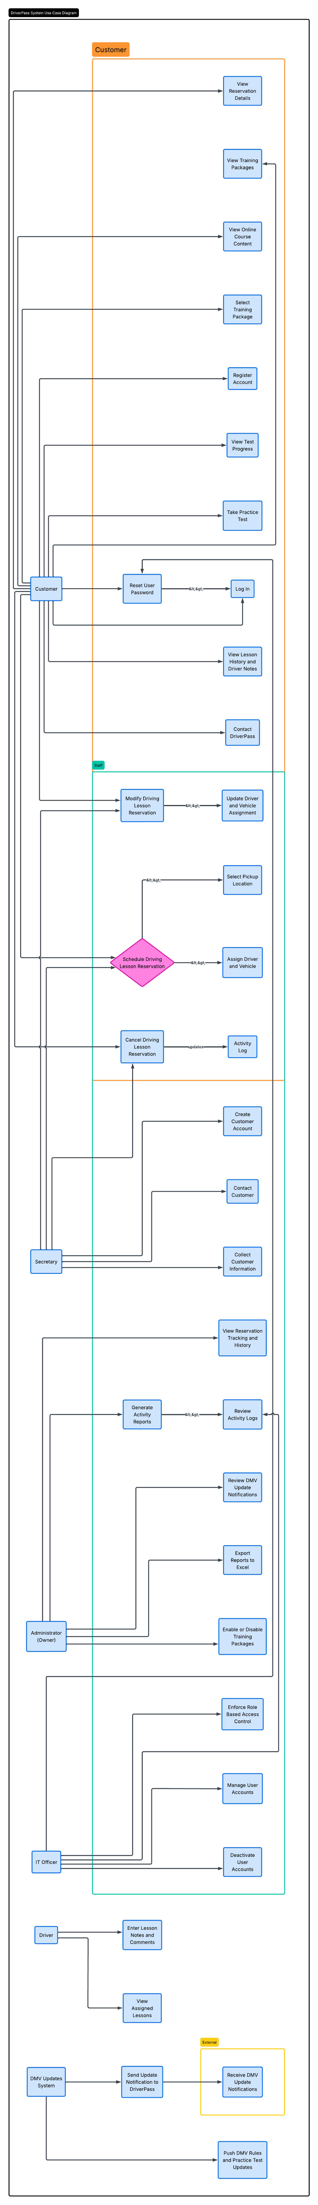
Figure 1. DriverPass System Use Case Diagram

UML Activity Diagrams
Two use cases were selected for activity diagram modeling: Schedule Driving Lesson Reservation and Take Practice Test. These represent the two highest-frequency workflows in the DriverPass system and directly address the client's core requirements.

Activity Diagram 1: Schedule Driving Lesson Reservation
This diagram models the end-to-end process of a customer scheduling a driving lesson. It uses three swim lanes — Customer, DriverPass System, and Staff — to show how responsibilities are distributed across actors. The decision node captures the availability check logic, and the diagram shows how the system handles both successful and unavailable booking scenarios.

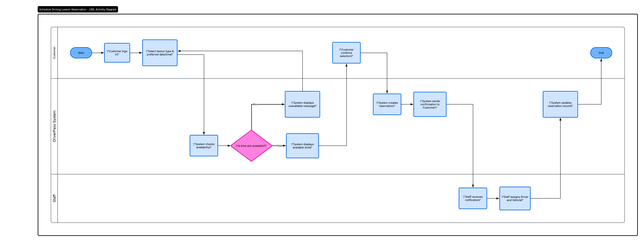
Figure 2. UML Activity Diagram — Schedule Driving Lesson Reservation

Activity Diagram 2: Take Practice Test
This diagram models the customer's practice test workflow from login through score review. Two swim lanes — Customer and DriverPass System — show the division between user actions and automated system processing. The decision node captures the loop that continues displaying questions until all are answered before allowing test submission.

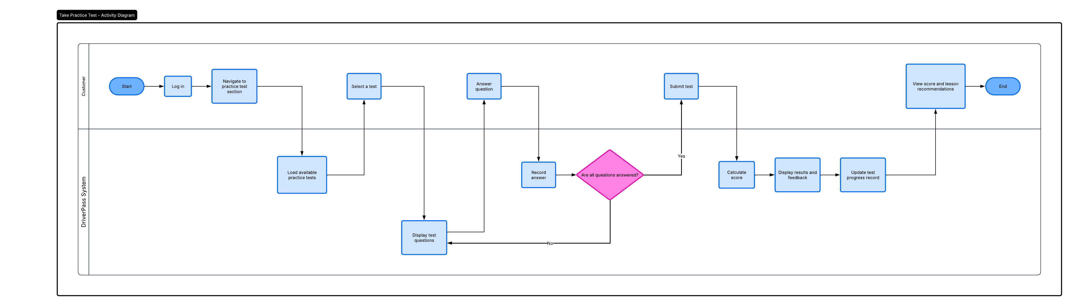
Figure 3. UML Activity Diagram — Take Practice Test

UML Sequence Diagram
The sequence diagram below models the Schedule Driving Lesson Reservation use case at the object interaction level. It shows the precise sequence of messages passed between five lifelines: Customer, DriverPass Web Interface, Reservation System, Database, and Staff Notification System. This diagram demonstrates how the system validates user credentials, queries available time slots, creates the reservation record, and notifies both staff and the customer upon confirmation.

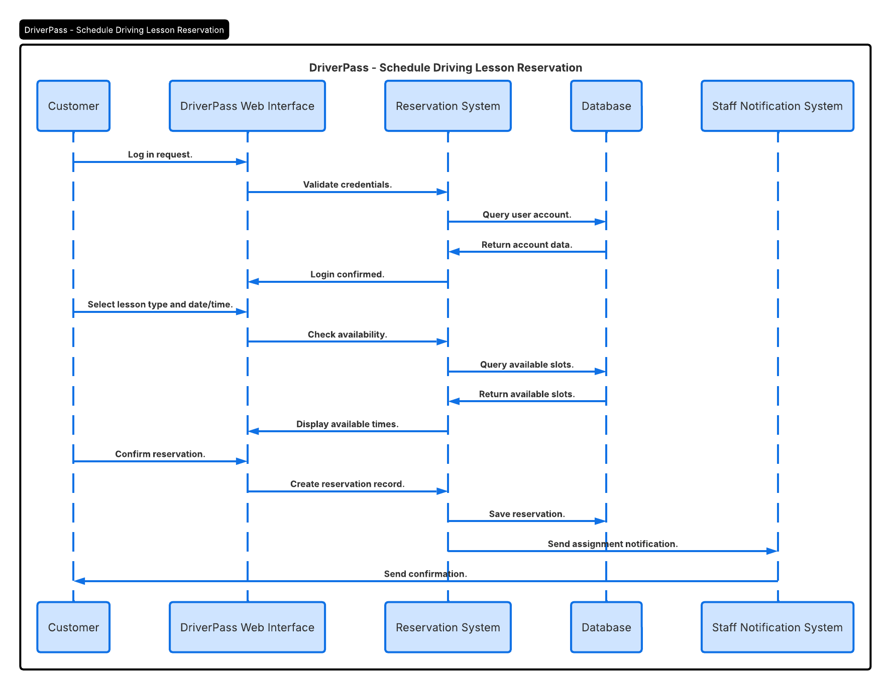
Figure 4. UML Sequence Diagram — Schedule Driving Lesson Reservation

UML Class Diagram
The class diagram below represents the data structure of the DriverPass system. It includes ten classes: User, Customer, Driver, Staff, Administrator, Reservation, Vehicle, TrainingPackage, PracticeTest, and ActivityLog. Inheritance relationships show that Customer, Driver, Staff, and Administrator all inherit from the base User class. Association relationships capture how customers place reservations, reservations are assigned to drivers and vehicles, customers select training packages and take practice tests, and staff and administrators generate activity logs.

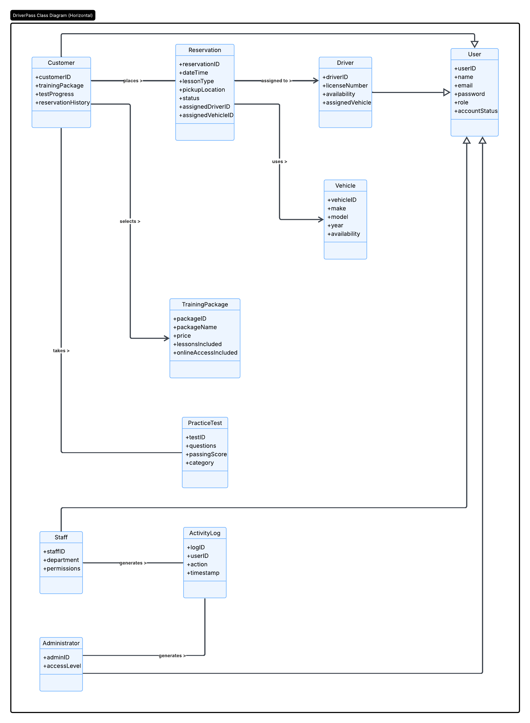
Figure 5. UML Class Diagram — DriverPass System

Technical Requirements

Hardware Requirements
The DriverPass system requires reliable server infrastructure to support concurrent users across web and mobile platforms. The production environment should include a minimum of two application servers with at least 16 GB RAM and quad-core processors to handle simultaneous scheduling, testing, and reporting requests. A dedicated database server with a minimum of 500 GB storage is required to support reservation history, user accounts, test records, and activity logs at scale. Load balancing hardware or software is recommended to distribute traffic evenly during peak usage periods such as evenings and weekends when customers are most likely to schedule lessons or take practice tests.

Customer-facing hardware requirements are minimal by design. The system must be accessible from any modern desktop, laptop, or mobile device with an internet connection and a supported web browser. No proprietary hardware is required on the customer side.

Software Requirements
The DriverPass system will be delivered as a cloud-hosted web application accessible through standard browsers including Chrome, Safari, Firefox, and Edge. The backend will require a web application framework capable of handling RESTful API requests, user authentication, and session management. A relational database management system (RDBMS) such as MySQL or PostgreSQL is required to store and query structured data across the User, Reservation, Vehicle, TrainingPackage, PracticeTest, and ActivityLog tables identified in the class diagram.

The system requires a secure email or SMS notification service for sending reservation confirmations to customers and assignment notifications to staff. An authentication library supporting role-based access control (RBAC) is required to enforce the permission boundaries identified in the use case diagram, ensuring that customers, staff, secretaries, administrators, and IT officers can only access functions appropriate to their role.

Integration with the DMV Updates System requires a secure API connection or data feed to receive rule changes and updated practice test content. The system must be capable of processing incoming DMV notifications and automatically updating practice test question banks without manual intervention.

Tools and Infrastructure
The system will be hosted on a cloud platform such as AWS, Google Cloud, or Microsoft Azure to ensure scalability, uptime, and geographic redundancy. Cloud hosting directly supports DriverPass's requirement for 24/7 system availability, as customers and staff need to access the system at any time.

SSL/TLS encryption is required for all data transmitted between users and the system. User passwords must be stored using a one-way hashing algorithm. Sensitive data including customer personal information and payment details must be encrypted at rest. These security measures address the client's stated concern about data protection and align with the role-based access control use cases captured in the use case diagram.

A backup and disaster recovery solution is required with a recovery point objective (RPO) of no more than 24 hours and a recovery time objective (RTO) of no more than 4 hours. Automated daily database backups must be stored in a separate geographic region from the primary hosting environment.

Administrative tools including a reporting dashboard, user account management interface, and activity log viewer are required to support the Administrator and IT Officer use cases identified in the use case diagram. These tools should be accessible through a secure admin portal separate from the customer-facing interface.

